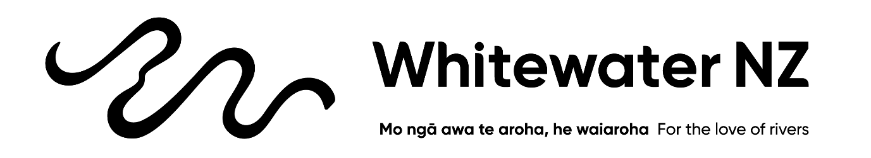
Whitewater NZ Submission Guide
Conservation Amendment Bill
Guide: First, navigate to the parliament's online submission form for the Conservation Amendment Bill: [CLICK HERE]
Then scroll down, and click I am submitting "As an individual" (or "On behalf of an organisation" if its relevant to your org).
Decide if you want the chance to make an oral submission to the committee? "Yes" or "No", hit next.
Add your contact details in the separate boxes, hit next.
Add your submission - you can write your own (and make it as personal and formatted as you want - include photos even) and upload it to their website, or scroll down to the online submission form (the quick and easy way):
The form has two boxes. Here's what goes in each.
Box 1: "I/We wish to make the following comments"
This is your bit. A few honest lines about who you are and why these rivers matter to you. Try not to copy the example directly - copies all get counted as one, so yours counts for more in your own words. You can write it like you'd tell a mate.
Box 2: "I/We wish to make the following recommendations"
This is the easy bit. Copy the four recommendations below and paste them straight in. Tweak if you want, or leave them exactly as they are.
Hit next, and make sure to submit before 11.59pm, Thursday 2 July. Then tell your paddling mates, friends, and family to do the same, the more of us who submit, the harder we are to ignore - For the love of rivers!
Look on the next page for your submission template…

Block A: paste into the COMMENTS box, then make it yours
I'm a whitewater paddler from [your town]. I've been paddling for [how many years], mostly on [rivers or region you paddle].
The rivers I love run through conservation parks, stewardship land and forest parks, which is exactly the land this Bill would make easier to sell or swap. Losing that land can mean losing the right to cross it, put in, take out or camp, even if the river itself stays.
[WRITE YOUR OWN BIT HERE. A few honest lines: a river you love, a trip with mates, teaching someone, a moment you won't forget. Why it has to stay wild for the paddlers who come after you. This is the part that counts.]
(Example for above, don't copy it, write your own: "The first West Coast river I ever ran was the Whataroa, three of my mates and me terrified and grinning through one of the most stunning gorges I have seen right in our NZ backyard. I've been back every Christmas since for an annual trip and I want my kids to get the same chance in those gorges.")
These are public places that belong to all of us. Please don't make them easier to sell, and please keep our access to rivers protected.

Block B: paste into the RECOMMENDATIONS box (you can delete any you don't agree with)
I recommend that the Committee:
- Does not make it easier to sell, exchange or dispose of public conservation land, and keeps the current strong protections in place.
- Keeps conservation as the primary purpose of the Conservation Act, and does not rush the change that makes economic development a core function of DOC (new section 6(ea)) without a full and proper public conversation.
- Keeps real decision-making and oversight with the public, the New Zealand Conservation Authority and Conservation Boards, including the right to be heard when land is sold or swapped.
- Guarantees that public access to rivers is protected whenever any conservation land is exchanged or disposed of.

